1. What is Object/Elements/POM Repository

Its collection of elements locators & business libraries in one place & its developed using POM design pattern

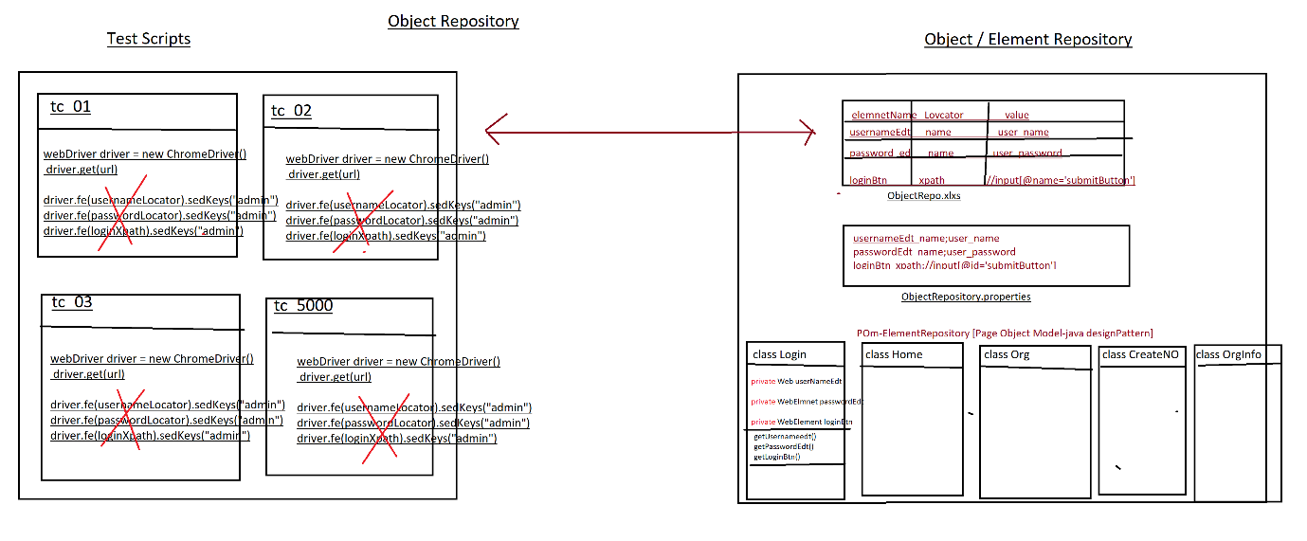

1. Why Object repository?

As per the rule of the automation, we should not hardcode[fixed]elements within test Scripts, instead we should get elements from Object Repository, because in Agile process due to frequent requirement changes, modification & maintenance of elements are tedious job

EG: below is the example of Gmail application GUI changes

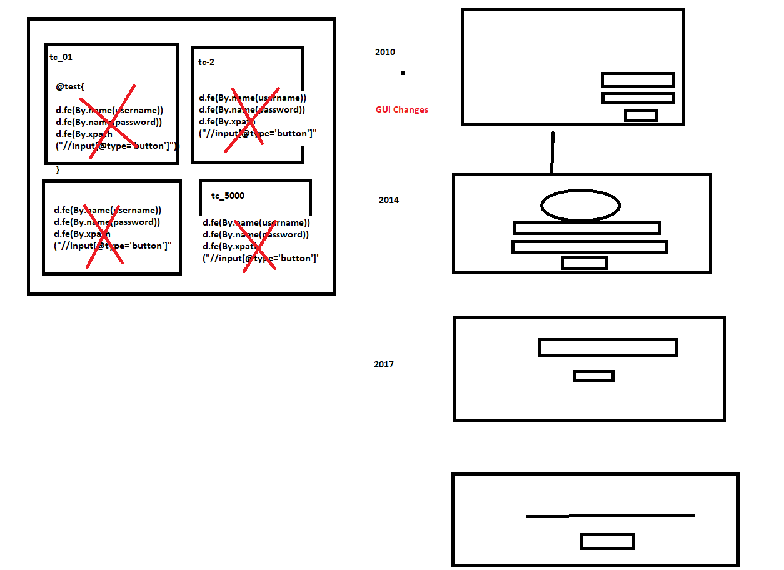

1. What are the advantages repository?
2. Reusability of elements, no need to write xpath & other locators again & again
3. Modification in Repository is easy, when GUI changes frequently
4. Maintenance is easy, because all the elements we kept in one place
5. Test Script Code will be Optimized via business reusable libraries
6. More Readability
7. Test Script development is faster due to business lib
8. Test Script is more robust
9. Handle StaleElementReferenceException.
10. What is POM?

POM is a java design pattern preferred by google to develop object repository.

1. Why POM?

It’s a well-organized structured design pattern, where we can maintain all the web elements in page wise, due to POM design pattern maintains & modification is easy & faster.

1. Advantages of POM:
2. Well organized structure
3. Handle StaleElementReferenceException.
4. Maintains & modification of element is easy
5. We can directly store Web Elements in java class
6. Better fit for Agile processes
7. Support Auto heal feature
8. Why @FindBy(locator) annotation instead of driver.findElement(“locator”)

Ans: To avoid StaleElementReferenceException

1. What is StaleElementReferenceException?

It’s one of selenium Exception, whenever webdriver try to identify an element, element was available in GUI, but at the time of performing an action on the elements element was not recognized due to page got refreshed or elements may become old or element not attached to page in such case we get StaleElementReferenceException

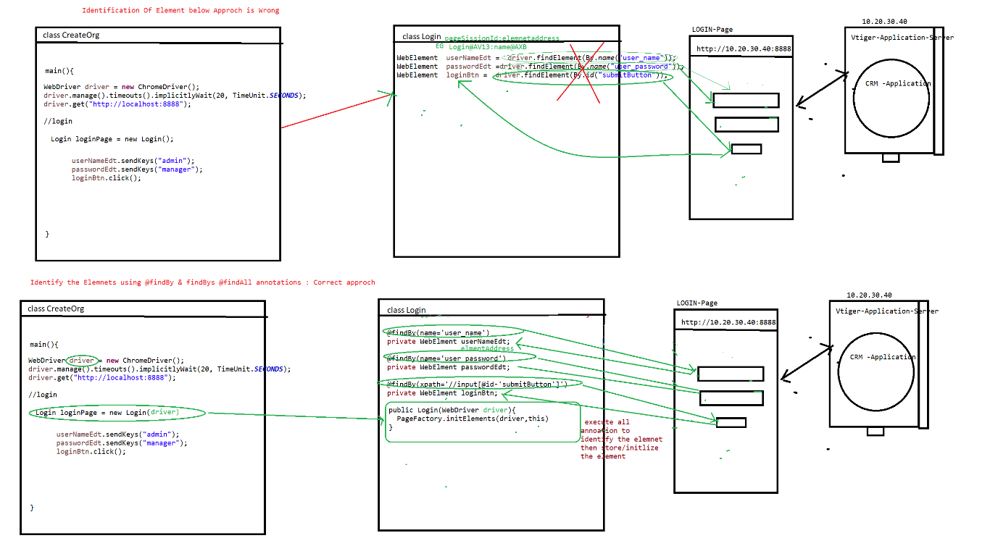

1. Rules of POM

Rule 1 : create separte java class for every page in a application & class name should be same page name

Rule 2 : Identify all the elements using @findBy, @findAll & @findbys annotations & store them in speific pom / java class (Element declartion)

Rule3: For Every POM class create Constructor to get an Object of the class & initialize the Page Elements, in order to initialize all the page Elements, we should use Pagefactory.initElement() (Element initialization)

Rule 4: declare all the WebElements as private & provide getters methods to accesses elements in testScripts class [this processes is called Encapsulation]

Note: To create getters methods inside the java class follow below steps

🡺place cursor inside the class🡺 Right click🡺source 🡺generate getters & setters 🡺 select the getters check box 🡺 click on ok button

Rule 5: Go to every page & identify the reusable business libraries & implement them in same POM class

1. Difference between POM & PageFactory design pattern?

POM is java design pattern, where we will maintain all the Web element locators in well-organized manner.

PageFactory it’s an extended design pattern of POM, which is used to create an Object to POM classes, & at the time of object creation it will execute all @findBy @findbys annotation then initialize all the elements.

Difference between @findBy, @findAll & @findBys annotation

All annotation available in Selenium webdriver, its traditional ways to identify the elements in GUI.

@findBy: used to identify the element using one locator or one condition

@findAll: it contains multiple @findBy annotation, it means we can identify the same element using multiple locator (multiple conditions), it will use OR condition during execution of locator

@findALL({@findBy(@id=’username’), @findBy(name=’user’)})

Private Webelements userNAmeEdt;

Note: using above concepts we can achieve **AutoHealing** technique

**AutoHealing**: during execution, if one locator fails to identify the element, it will retry to identify the same element using another locator

@FindBys: it contains multiple @findBy annotation, it means we can identify the elements using multiple locator (multiple conditions), it will use AND condition during execution of locator

@findBys({@findBy(@id=’username’), @findBy(name=’user’)})

Private Webelements userNAmeEdt;

Project Structure

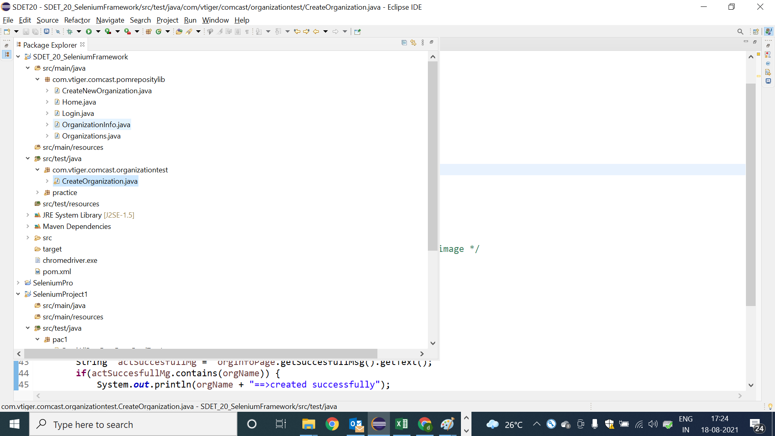

POM Classes: Login

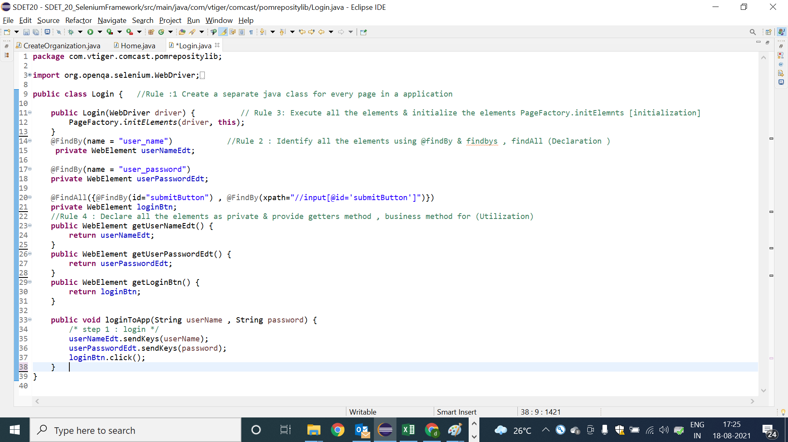

POM Classes: Home

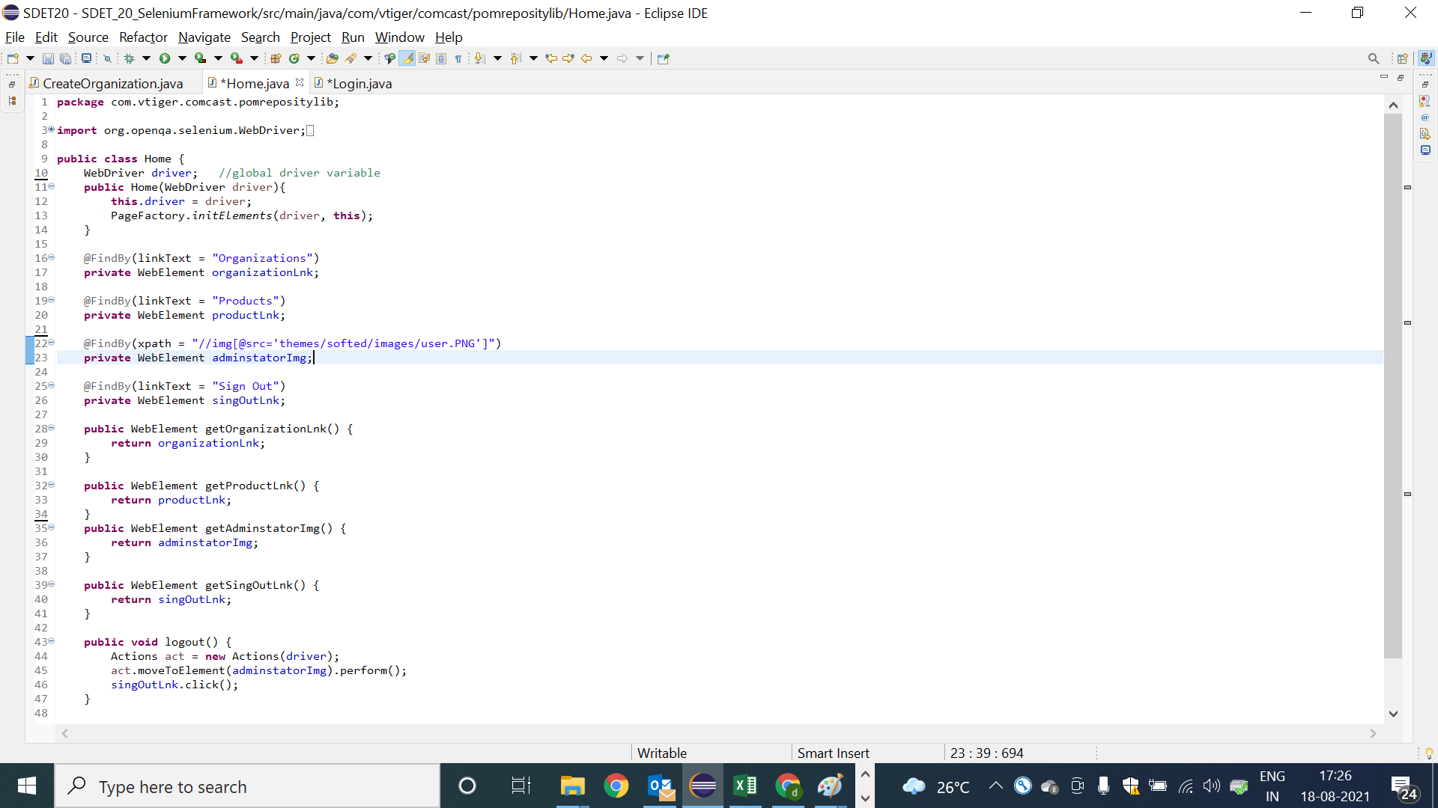

POM class: Organization

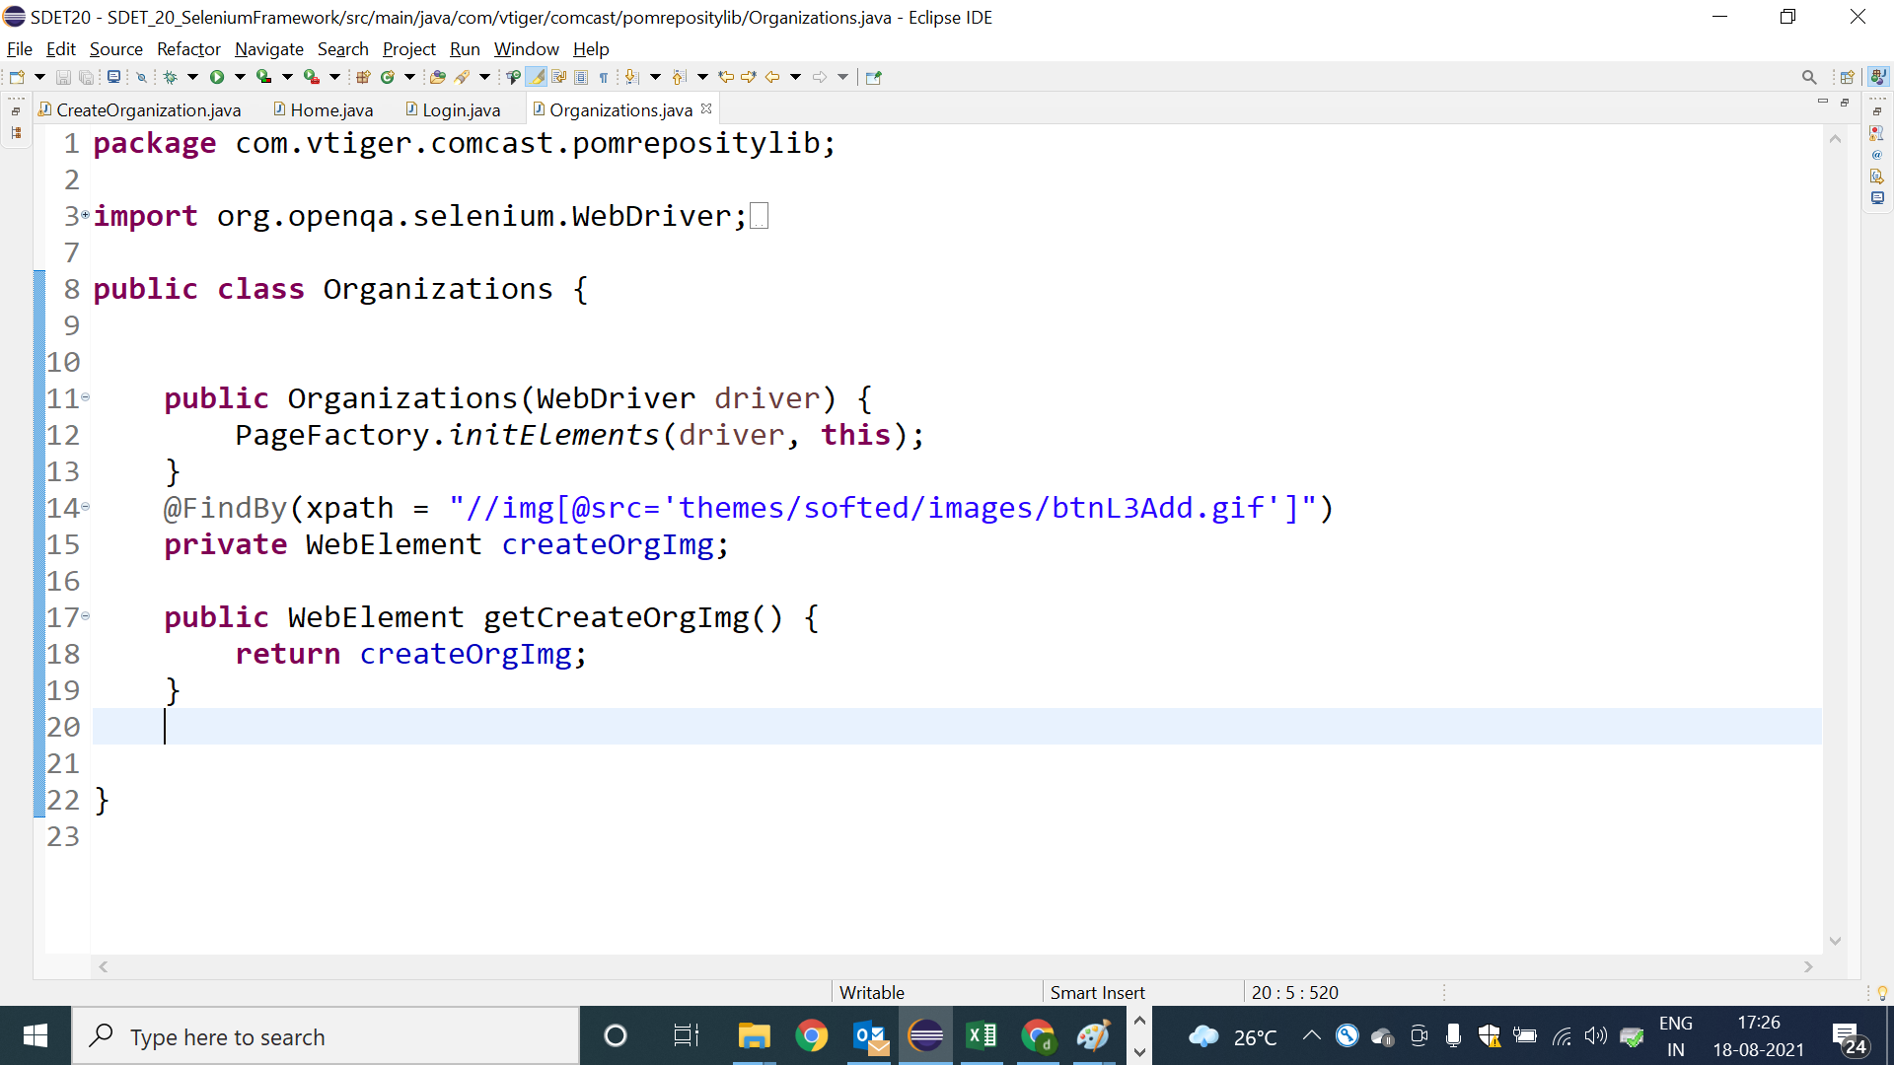

POM class: Create new Organization Page

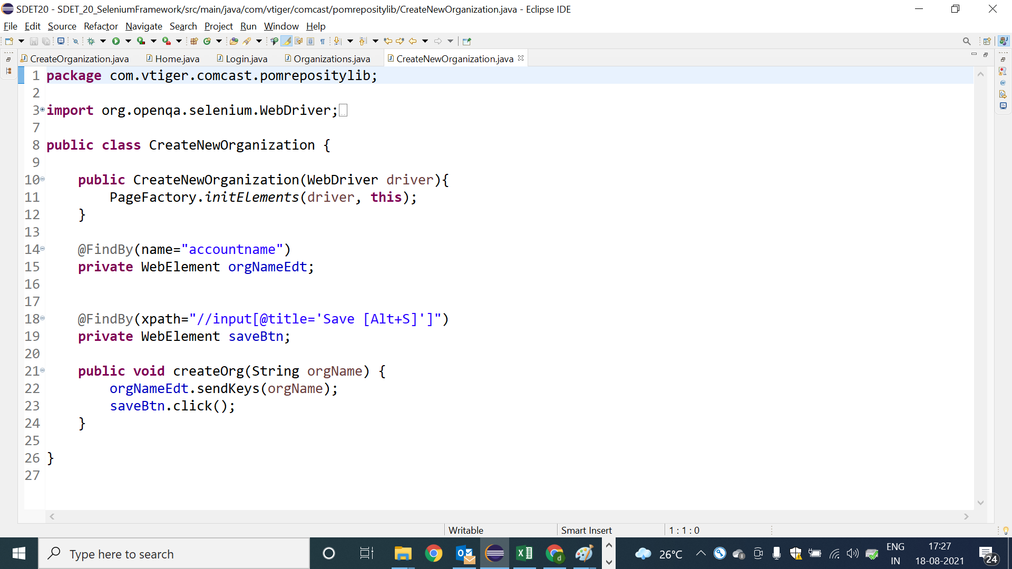

POM class: OrganizationInfo

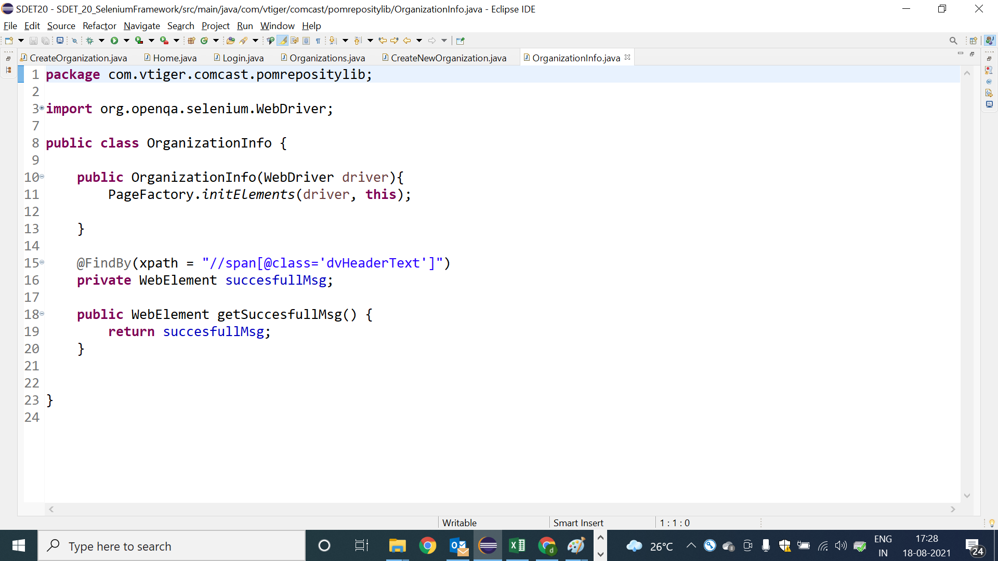

Test Scripts using POM class

